Chapter 3, Solution 13

Calculate v₁ and v₂ in the circuit of Fig. 3.62 using nodal analysis.
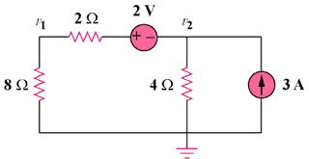
10 V
15 A

Figure 3.62
For Prob. 3.13.

Solution

At node number 2, [((v₂ + 10) – 0)/10] + [(v₂–0)/4] – 15 = 0 or
(0.1+0.25)v₂ = 0.35v₂ = –1+15 = 14 or

v₂ = 40 volts.

Next, I = [(v₂ + 10) – 0]/10 = (40 + 10)/10 = 5 amps and,

v₁ = 8x5 = 40 volts.

